**DBMS SETUP FOR MAC**

**STEPS**

**1 Setup of Xcode**

* **Download Xcode From App Store**
* **Register Account By :**
* **Click on Xcode on top of screen**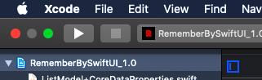
* **Click on Preferences**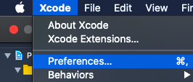

* **A window appears**
* **Click on accounts**
* **Tap ‘+’ icon and register using your Apple ID and Password.**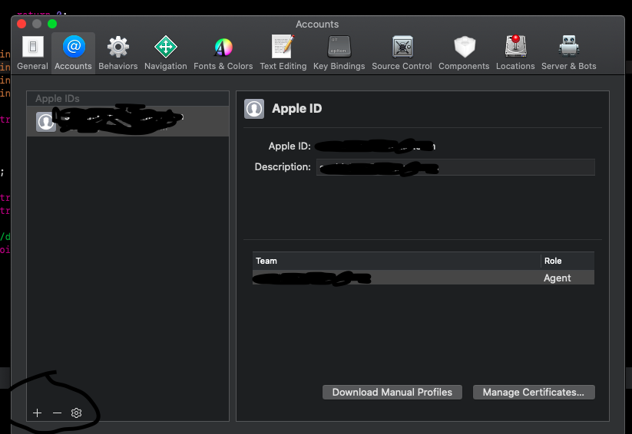
  + - * **Now Click on the blue button which has your project name in top left hand side .**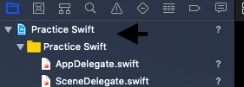

* **Click on Signing and Capabilities.**
* **Change your Team to your name using drop down menu.**

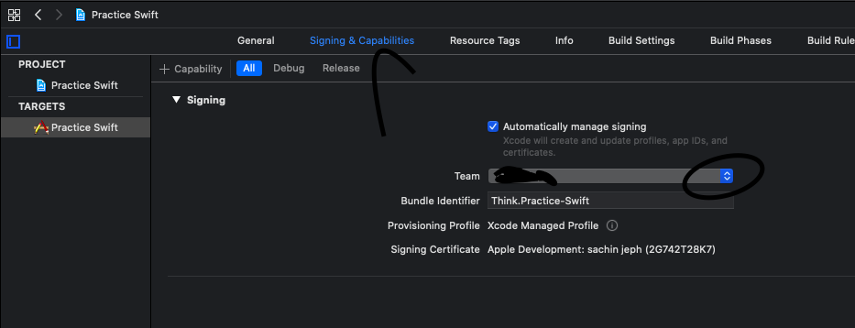

**2 Setup of Xcode Project**

**Download .cpp files from the below link.**

<https://github.com/sachinELEVEN/Setup-For-DBMS-With-Code.git>

-Github userName ‘sachinELEVEN’

**Import these .cpp files in your Xcode Project.**

**3 Importing curl Library for Networking of Xcode**

**Click on the blue button which has your project name in top left hand side .**

**Click on add Frameworks and Library.**

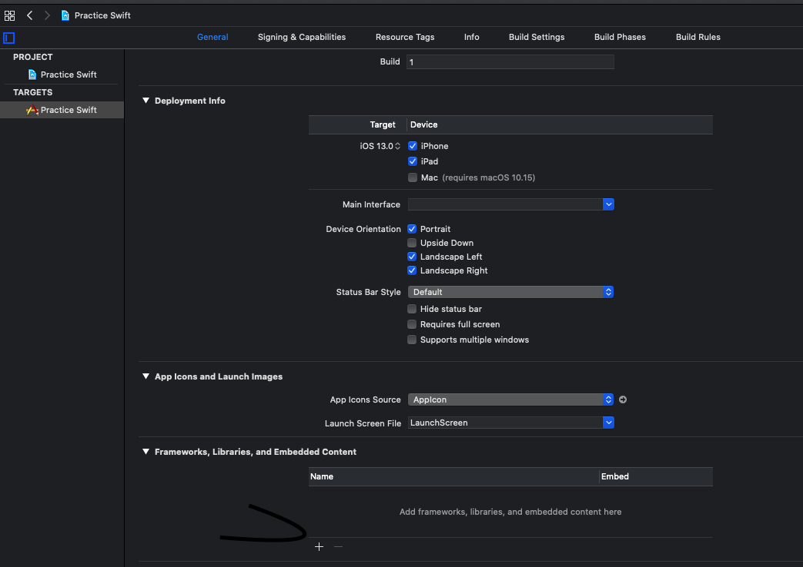

* **Search for ‘curl’.**
* **Double click on ‘curl.4.tbd’.**
* **You can see this library gets added to your project.**

**NOW YOUR PROGRAM SHOULD SUCCESSFULLY COMPILE.**

**TO COMPILE PRESS ‘CMD+R’**

**4 Setup of XAMPP**

* **Download XAMPP**
* **Open XAMPP and Click Start**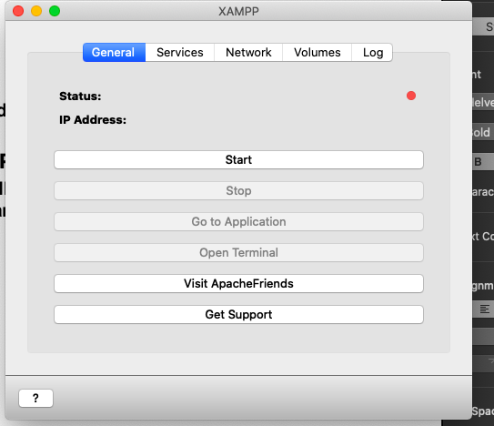
  + **Click on Network and turn on localhost 8080**
* **Click on volumes then on mount then click explore.**
* **Search ‘htdocs’ in this folder. Open it.**
* **Download the .php file from the below link.**

<https://github.com/sachinELEVEN/Setup-For-DBMS-With-Code.git>

-Github userName ‘sachinELEVEN’

* **Paste this .php file directly in the htdocs folder.**